INDPIRED  INSANITY  SC28 | 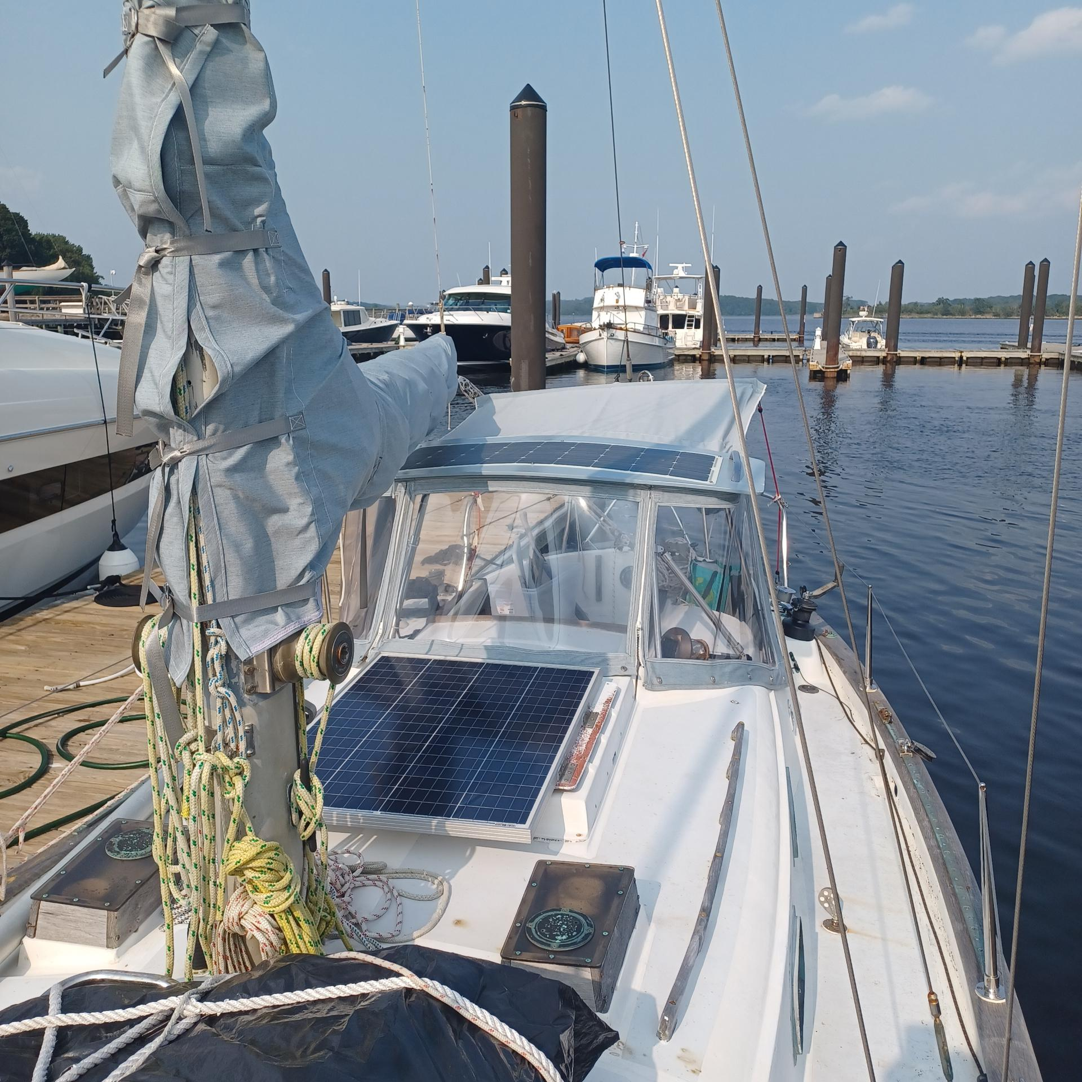
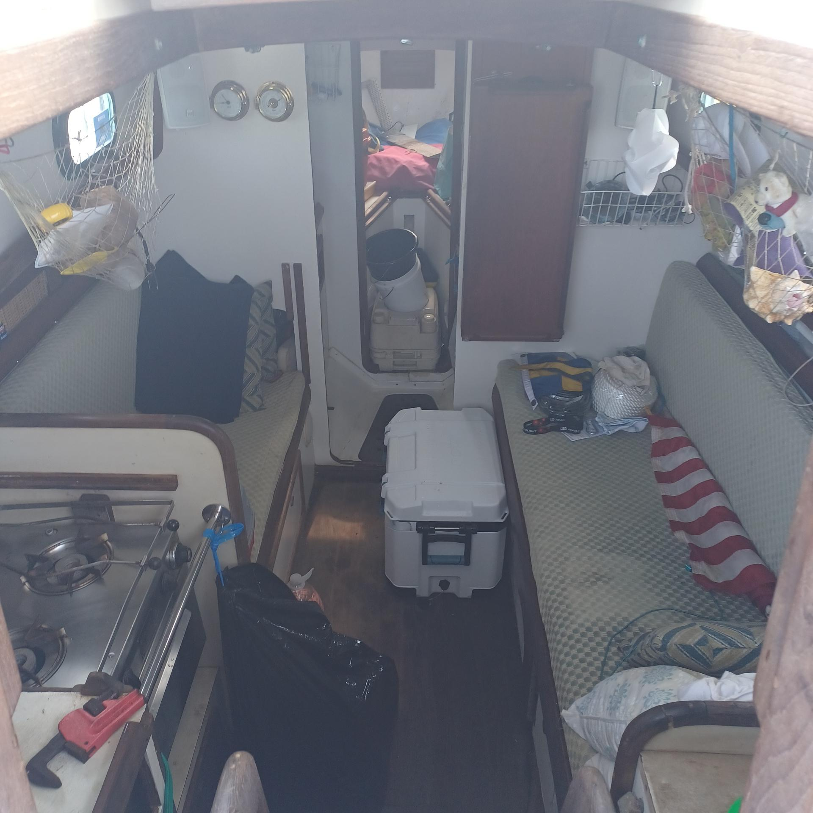 | 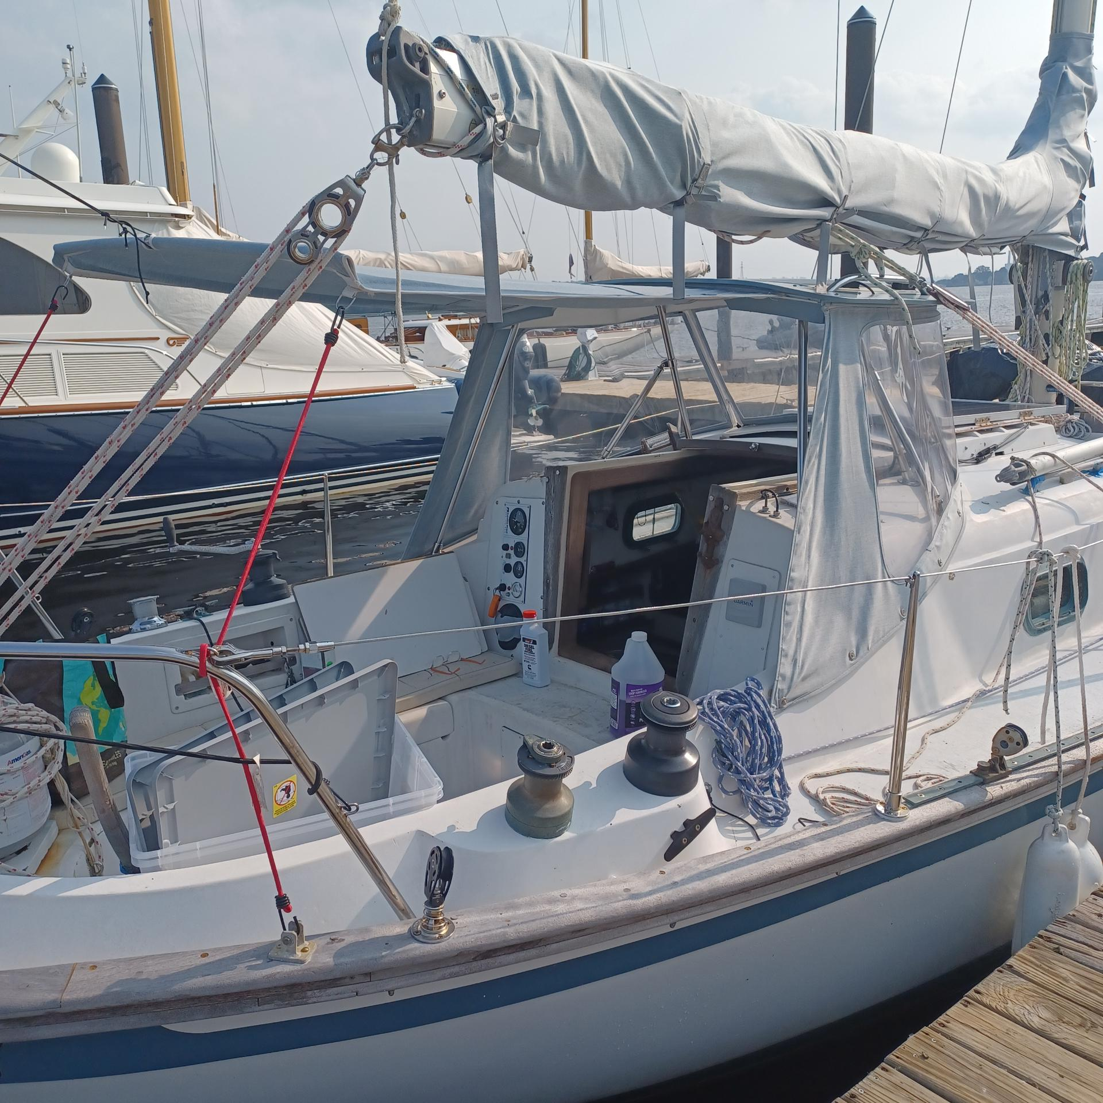
  - Refit SC28 by two-time solo world sailor, Donna Lange

Www.sailtwicearound.com
SV_ Inspired Insanity would be a great weekender for a family, Wednesday Race nights, or the ultimate world cruiser’s dream come true for 1 or 2 people.
Engine rebuilt in 2022, New panel and engine harness, new custom hard dodger, functional set of sails, lots of real world cruising experience, tools, and turn-key. She was sailed from FL to MA spring 23’.

Turn-key Cruising or Family Weekender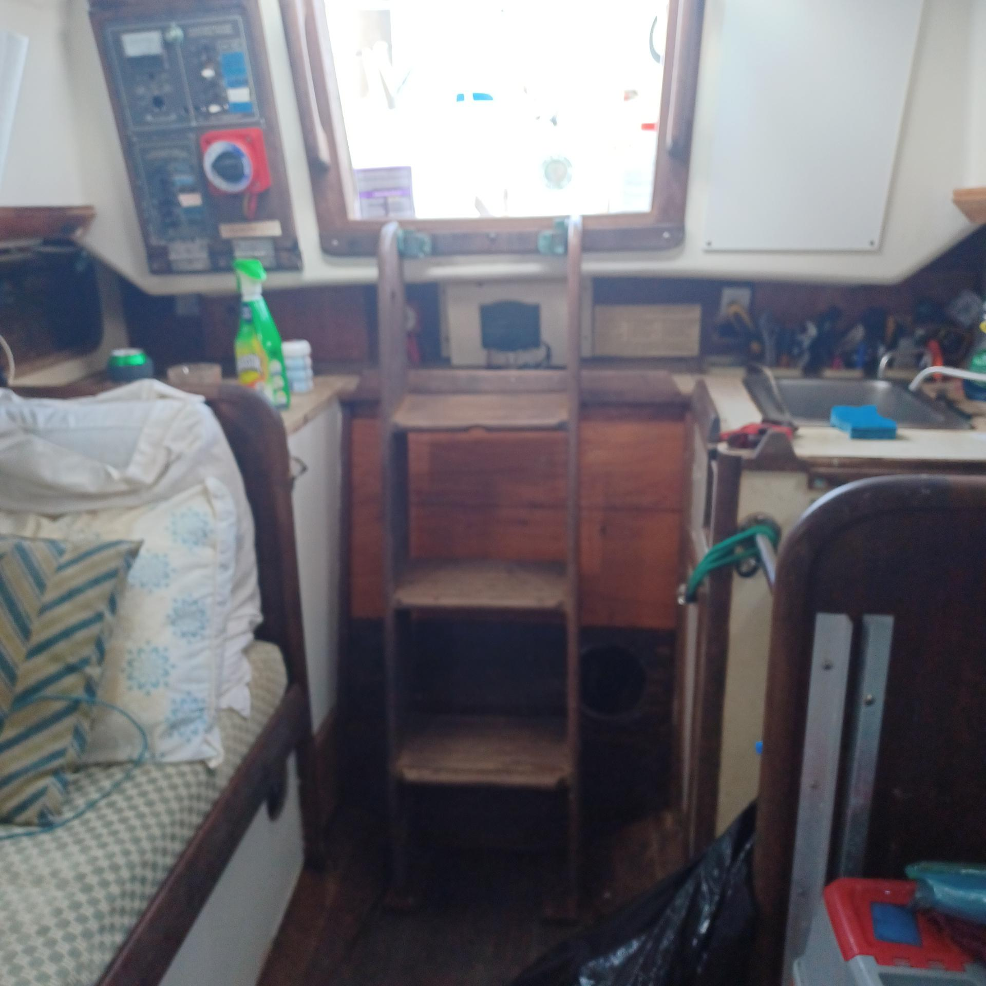

Roomy design
Optimum room for full galley, large salon berth, V-drive transmission makes the engine assembly space friendly, leaving more salon foot room. Electric panel relocated inside salon. Batteries are waterproof high and dry in the icebox space. Ample power for dc cooler.
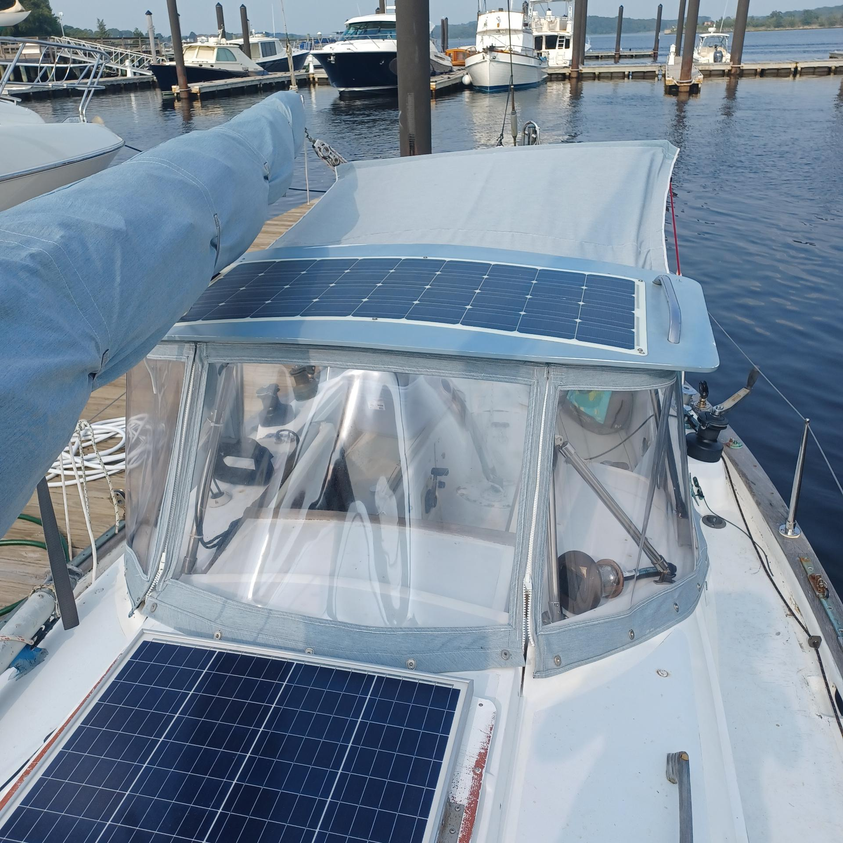
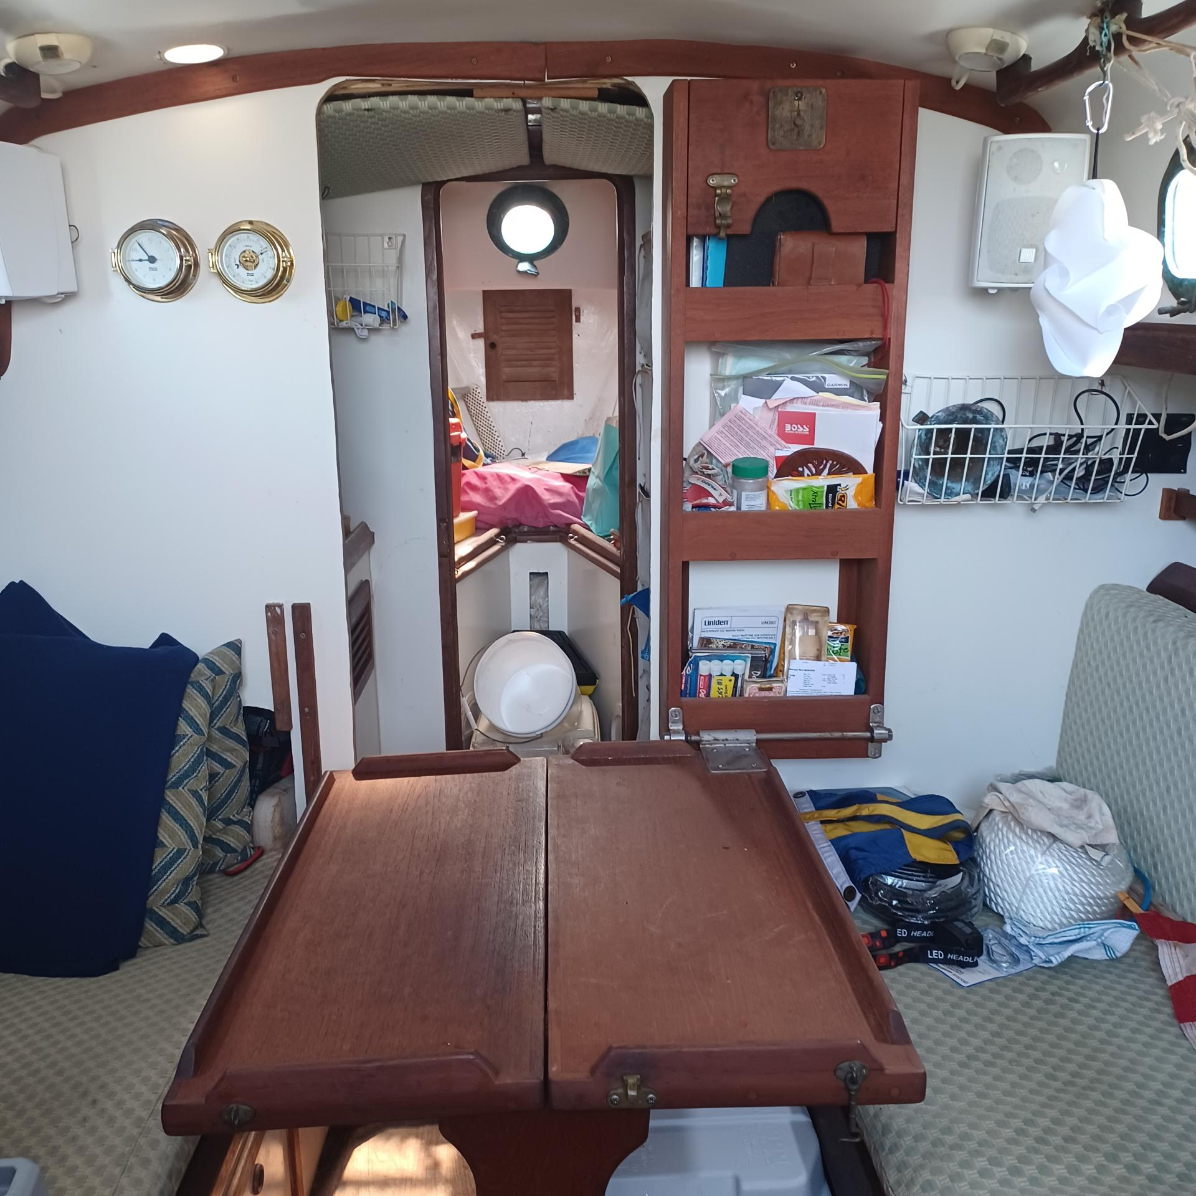
Green Energy happy. II has 2 solar panels in parallel, as well as a wind generator for ample green generation of power. The brand new custom hard dodger and Bimini, plus sail cover are a great e.
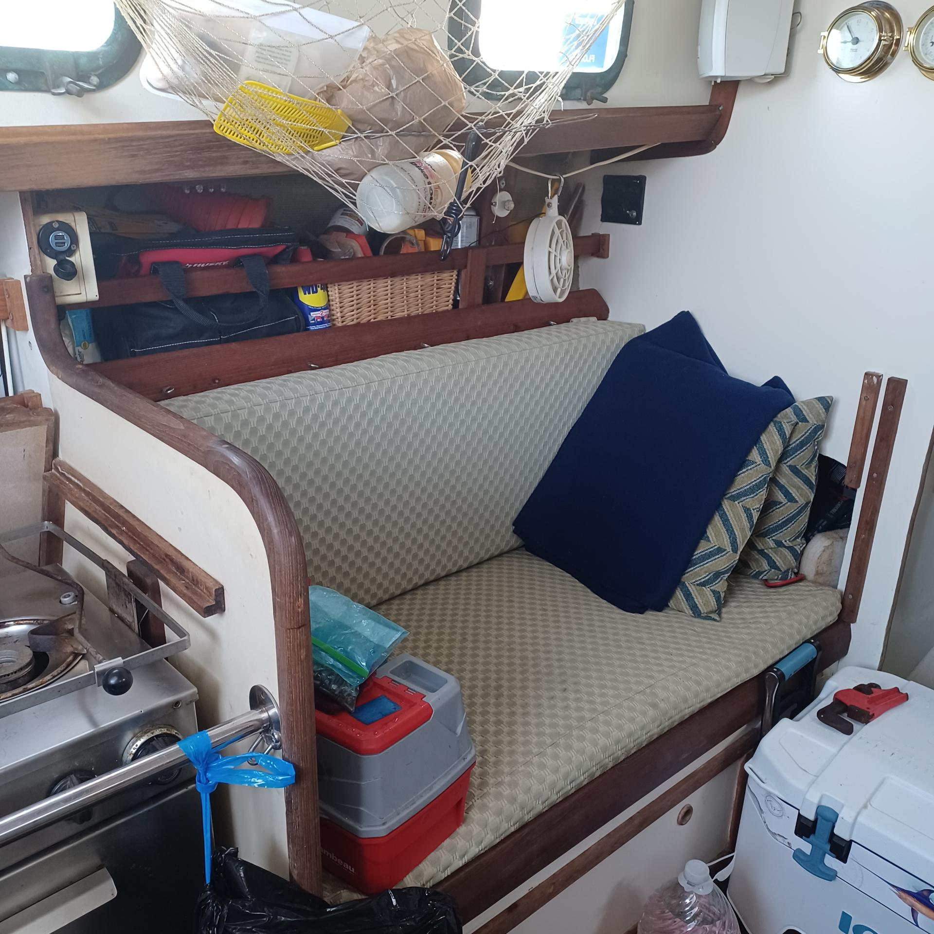

Interior refit
In 2013, the interior had a complete lift, with new wall coverings and upholstery, teak fiddles, a new bulkhead, formica sealing of walls, and new paint throughout.

